**ABSTRACT:**

The "Financial Case Study of YouTube" topic is exciting and has garnered attention from researchers and scholars in finance and banking. The study will employ a qualitative research methodology, using semi-structured interviews and content analysis to gather data from creators and viewers of financial case studies on YouTube. The study aims to comprehensively analyze YouTube's revenue model and the challenges and opportunities of monetizing content on the platform. The research methodology involves a systematic review of the literature on YouTube's economic case study, including academic articles, reports, and financial statements.

The literature review reveals that YouTube's revenue model is primarily based on advertising, with content creators receiving a share of advertising revenue through the YouTube Partner Program. YouTube's strong revenue growth has played a significant role in driving the success of Alphabet and its stock price on the NASDAQ stock exchange. However, content creators face challenges such as demonetization, inconsistent revenue streams, and changes to the platform's algorithms.

The research project also examines the broader impact of YouTube's revenue model on the media industry, including the disruption of traditional media business models and the shift toward online advertising and digital media. The study concludes with a discussion of the implications of the findings for content creators, investors, and policymakers. The research project provides valuable insights into the financial case study of YouTube and contributes to the growing body of literature on digital media and online advertising.

The project includes data and its analysis from primary and secondary sources.

**INTRODUCTION:**

YouTube is a video-sharing platform created in February 2005 by three former PayPal employees: Chad Hurley, Steve Chen, and Jawed Karim. The idea for YouTube came about after the three founders had difficulty sharing videos from a dinner party they had attended. They saw a need for an easy-to-use platform where people could upload and share videos with others.

The first video uploaded to YouTube was titled "Me at the Zoo" and featured Jawed Karim at the San Diego Zoo. The video was uploaded on April 23, 2005, and is available on the site today. The site quickly gained popularity and was purchased by Google in November 2006 for $1.65 billion. Over the years, YouTube has undergone many changes and additions. In 2007, YouTube launched its partner program, which allowed creators to earn money from their videos. In 2010, the site introduced live streaming, and in 2011, it launched its first original channels. In 2012, YouTube announced that it had reached one billion monthly active users.

In recent years, YouTube has faced controversy and criticism over hate speech, misinformation, and copyright infringement. The site has taken steps to address these issues, including implementing stricter content policies and improving its algorithm to prioritize trustworthy sources.

Today, YouTube is one of the most popular websites, with over two billion monthly active users. The site is used by people worldwide to share and consume video content on a wide range of topics, from entertainment to education to news and more.

YouTube's financial case study focuses on the company's revenue generation and profitability. The platform is primarily monetized through advertising, with most of its revenue coming from display and video ads. YouTube also offers premium subscriptions and content purchases, but these sources of income are relatively small compared to its advertising revenue.

In 2020, YouTube generated $19.8 billion in advertising revenue, an increase of 30% from the previous year. This revenue growth was driven by increased engagement on the platform due to the COVID-19 pandemic and growth in YouTube's direct response advertising business. The company's total revenue for the year was $23.7 billion, up from $15.1 billion in 2019.

However, YouTube's profitability is not disclosed separately from its parent company, Google. As a result, it is difficult to determine how profitable YouTube is on its own. However, YouTube is widely believed to be good, given its significant revenue and the relatively low cost of content creation and distribution on the platform.

Overall, YouTube's financial case study highlights the platform's success as a major player in the online advertising industry and its ability to generate significant revenue through its massive user base and engagement.

**REVIEW OF LITERATURE:**

A literature review refers to the critical analysis and evaluation of existing published research, scholarly articles, books, and other relevant sources of information related to a particular research topic. It involves examining and synthesizing previous studies' findings, theories, and arguments and identifying gaps, inconsistencies, and areas for further investigation.

**1. Introduction to YouTube**

YouTube is a video-sharing platform launched in 2005. It has since become one of the largest social media platforms in the world, with over 2 billion monthly active users. YouTube has enabled individuals and businesses to create and share content with a global audience, making it a powerful marketing and brand-building tool.

**2. YouTube as a Business**

YouTube is a subsidiary of Google, which acquired the company in 2006 for $1.65 billion. Since then, YouTube has become a significant revenue generator for Google, with advertising being the primary source of revenue. YouTube also offers paid subscriptions and other revenue-generating services for content creators.

**3. Impact of YouTube on the Media Industry**

YouTube has disrupted traditional media by enabling individuals and small businesses to create and distribute content. This has democratized content creation and distribution, representing various voices and perspectives. However, this has also led to concerns about the quality and integrity of content on the platform.

**4. Regulatory Issues and Controversies**

YouTube has faced several regulatory issues and controversies, including concerns about content moderation, copyright infringement, and spreading misinformation. In 2019, YouTube was fined $170 million by the Federal Trade Commission for violating child privacy laws. In 2020, YouTube was criticized for handling hate speech and misinformation about the COVID-19 pandemic.

**5. Future of YouTube**

The future of YouTube is the subject of much speculation and debate. Some analysts predict that the platform will continue to grow and dominate the digital media landscape, while others suggest emerging competitors may challenge its dominance. The emergence of new technologies, such as virtual and augmented reality, may also impact the future of YouTube.

In conclusion, the literature on the "Financial Case Study of YouTube" is diverse and multi-faceted. It covers various topics, including the business model of YouTube, its financial performance, its impact on the media industry, regulatory issues and controversies, and the platform's future. Future research in this area will likely continue to explore these themes and shed light on the ongoing evolution of YouTube as a business and a cultural phenomenon.

A review of the literature on the financial case study of YouTube reveals that the platform's revenue model is primarily based on advertising. Research studies have shown that advertising is the primary source of revenue for YouTube, with content creators receiving a share of advertising revenue through the YouTube Partner Program. The program allows eligible content creators to monetize their channels by displaying ads on their videos.

Several studies have also focused on the impact of YouTube's advertising revenue on the parent company, Alphabet Inc. Research has shown that YouTube's strong revenue growth has played a significant role in driving the success of Alphabet and its stock price on the NASDAQ stock exchange. This is due to YouTube's massive user base and engagement, which allows advertisers to target specific audiences and charge a premium for advertising.

Furthermore, studies have highlighted the challenges and opportunities of monetizing content on YouTube. While the platform offers several monetization options, such as premium subscriptions and content purchases, research has shown that content creators face challenges such as demonetization, inconsistent revenue streams, and changes to the platform's algorithms.

In addition, research has also explored the impact of YouTube's revenue model on the broader media industry. Some studies have shown that the platform's ad-based revenue model has disrupted traditional media business models, leading to a shift toward online advertising and digital media.

Overall, the literature on the financial case -the study of YouTube highlights the importance of advertising as the primary source of revenue for the platform, its impact on the parent company's stock price, challenges and opportunities of monetizing content, and the broader impact on the media industry.

**NEED OF STUDY:**

A financial analysis of YouTube would be helpful for a variety of reasons. Here are a few potential reasons why someone might want to conduct economic research on YouTube:

* **Investment decisions:** Whether individual or institutional, investors may want to analyze YouTube's financials to determine whether it is a sound investment opportunity. A financial analysis would provide information on YouTube's revenue streams, profit margins, and growth potential, among other things.
* **Business decisions:** Companies that work with YouTube, such as advertisers or content creators, may want to analyze YouTube's financials to understand how the platform's performance could impact their businesses. For example, a content creator might want to analyze YouTube's revenue-sharing model to determine whether it is worth investing time and resources into creating content for the platform.
* **Industry analysis:** A financial analysis of YouTube could also help understand the broader online video industry. For example, an analyst might compare YouTube's financials to other video-sharing platforms to determine which ones are most successful and why.
* **Public interest:** Finally, a financial analysis of YouTube could interest the general public. YouTube is one of the most popular websites in the world, and many people are curious about how it makes money and its financial performance. An economic analysis would provide insights into these questions and help people better understand the platform.
* **Ethical considerations:** Researching YouTube's financial content raises ethical considerations, such as privacy concerns for creators and viewers. A sound research methodology should include ethical considerations, such as obtaining informed consent and protecting the confidentiality of participants.
* **Evaluating the quality of existing research:** A literature review helps in assessing the quality of existing research and identifying the strengths and limitations of previous studies. This can inform the development of a more robust research methodology for the financial case study on YouTube.

**RESEARCH GAP:**

Some references from previous research papers are required to finish the study. A few errors were discovered during an investigation of those studies.

1. [**https://chillital.com/youtube-case-study/**](https://chillital.com/youtube-case-study/)

* Focused on only one channel of growth,
* Ignored the overall market ecosystem,
* Content marketing of one channel only, not overall.

1. [**https://www.slideshare.net/emmaspyramediastudies/case-study-youtube**](https://www.slideshare.net/emmaspyramediastudies/case-study-youtube)

* Nothing about Finance.
* Only youtube history or descriptions.

1. [**https://ieeexplore.ieee.org/document/9536986**](https://ieeexplore.ieee.org/document/9536986)

* No stock analysis
* Only focusing on two specific youtube channels
* No financial-related data or term
* Only concentrate on brand activity engagement

1. [**https://www.newamerica.org/oti/reports/why-am-i-seeing-this/case-study-youtube/**](https://www.newamerica.org/oti/reports/why-am-i-seeing-this/case-study-youtube/)

* Focused only on the recommendation system
* It does not talks about revenue generation and profit maximization,
* They did not take any primary data to interpret and make a decision instead, they took secondary data.

1. [**https://bootcamp.uxdesign.cc/ux-case-study-youtube-854c88ae291**](https://bootcamp.uxdesign.cc/ux-case-study-youtube-854c88ae291)

* This research paper focused on the user side only, like how to make users more productive and utilize the content efficiently. Despite the growing body of literature on YouTube and its revenue model, there are several research gaps that this finance research project aims to address.

1. [**https://www.vireovideo.com/case-studies/briogeo-case-study/**](https://www.vireovideo.com/case-studies/briogeo-case-study/)

* This case study mainly focused on one youtube channel and its growth and actual financial strategy applied to improve the market reach.

1. [**https://medium.com/@thesatishraju/youtube-channel-growth-case-study-user-study-52d87ea0e8c7**](https://medium.com/@thesatishraju/youtube-channel-growth-case-study-user-study-52d87ea0e8c7)

* This research paper talked about self-growth on youtube.
* It did not relate to any financial topic for their growth.

1. [**https://growthmodels.co/youtube-marketing/**](https://growthmodels.co/youtube-marketing/)

* This case study talks about the growth of the influencer. And criticizes the income that is paid out to the YouTubers.

1. [**https://sites.bu.edu/cmcs/files/2014/01/youtube.pdf**](https://sites.bu.edu/cmcs/files/2014/01/youtube.pdf)

* Lack of recent information
* Limited analysis of marketing strategies
* Over emphasis on Asian Race
* lack of meaningful comparisons

1. [**https://www.studocu.com/in/document/indian-institutes-of-management/marketing-management/youtube-for-brands-case-analysis/8571811**](https://www.studocu.com/in/document/indian-institutes-of-management/marketing-management/youtube-for-brands-case-analysis/8571811)

* The case study mentions statistics about YouTube viewers and TrueView ads, but it does not provide any sources for these statistic
* The case study presents a very simplistic analysis of the TrueView initiative and its effectiveness as an advertising format
* The case study does not provide any information about the specific brands or products that are being advertised using YouTube and TrueView ads
* The case study only focuses on the potential benefits of TrueView ads and does not address any potential drawbacks or limitations

Firstly, there is a lack of comprehensive analysis of YouTube's revenue model and its impact on Alphabet's financial performance. Although there have been studies on YouTube's advertising revenue, exploring other revenue streams and their contribution to Alphabet's overall revenue is necessary.

Secondly, there is a need to understand the challenges and opportunities of monetizing content on YouTube. While the YouTube Partner Program allows content creators to earn revenue from advertising, challenges, such as demonetization and inconsistent revenue streams, need to be addressed.

Thirdly, there is a gap in the literature on the broader impact of YouTube's revenue model on the media industry. While there have been studies on the disruption of traditional media business models, there is a need to explore the implications of YouTube's revenue model for advertising revenue, content creation, and distribution.

Overall, the research gap in the finance research project on the financial case study of YouTube is the need for a comprehensive analysis of YouTube's revenue model, its impact on Alphabet's financial performance, the challenges and opportunities of monetizing content on the platform, and the broader impact of YouTube's revenue model on the media industry.

**RESEARCH METHODOLOGY:**

The research methodology for a financial case study on YouTube will involve quantitative and qualitative research methods. The following are the steps that will be followed in conducting the research. A sound research methodology is critical for ensuring that the research study is conducted rigorously and systematically and that the results are valid, reliable, and helpful in informing decision-making.

Some of the critical components of the research methodology include:

**Objectives of the Study:**

The study's objective of the financial case study on YouTube is to analyze the company's financial performance and revenue generation strategies. Specifically, the purposes of the study are:

* To examine YouTube's revenue generation strategies and analyze its primary source of revenue.
* To analyze YouTube's financial performance over a specific period using quantitative techniques such as ratio analysis, trend analysis, and regression analysis.
* To identify factors contributing to YouTube's financial success, such as user engagement, advertising revenue, and premium subscriptions.
* To investigate the impact of external factors such as competition, changes in consumer behavior, and economic conditions on YouTube's financial performance.
* To provide recommendations for improving YouTube's financial performance based on the study's findings.

Overall, the study's objective is to provide insights into YouTube's financial performance and identify areas for improvement to inform future financial decisions.

**Research Design:**

The research design for the study will be a descriptive case study approach. This approach will be used to analyze and describe the financial performance of YouTube. The data collection will explore the company's financial statements and other relevant financial data.

**Variables of study:**

The study variables for the financial case study on YouTube are

* **Ownership:**

YouTube is a subsidiary of Alphabet Inc., a publicly traded company on the NASDAQ stock exchange. Therefore, the major shareholders of YouTube are also the major shareholders of Alphabet Inc.

As of 2021, the largest shareholders of Alphabet Inc. are institutional investors such as Vanguard Group, BlackRock, and State Street Corporation. These investors collectively own over 15% of the company's outstanding shares.

Other significant shareholders of Alphabet Inc. include the company's founders, Larry Page and Sergey Brin, who collectively own about 10% of the company's outstanding shares. Current CEO Sundar Pichai also holds a significant number of shares in the company.

In addition to these major shareholders, many individual investors own shares in Alphabet Inc. through direct ownership or mutual funds and exchange-traded funds (ETFs).

Overall, Alphabet Inc.'s diverse shareholder base includes a mix of institutional investors, founders, executives, and individual investors.

And about the CEOs for management of all policies and services,

Since its inception in 2005, a CEO has run YouTube, which has continued to operate under this structure even after being purchased by Google. Neal Mohan, who was chosen on February 16, 2023, is the current CEO.

List of CEOs.

* Chad Hurley (2005–2010).
* Salar Kamangar (2010–2014).
* Susan Wojcicki (2014–2023).
* Neal Mohan (since February 2023).
* **Finances:**

Before 2020, Google did not disclose the expenditures associated with maintaining YouTube, and revenues for that year were described as "not material" in a regulatory filing. A Forbes magazine story from June 2008, which noted an increase in advertising sales, estimated the 2008 revenue at $200 million. An estimated $3.7 billion in earnings from YouTube's advertising program was made in 2012. According to eMarketer, it nearly doubled in 2013 and was predicted to reach $5.6 billion; other sources put the figure at $4.7 billion.

Most YouTube videos are sponsored by advertising and available for free to watch. A pilot program for 53 subscription channels on YouTube with monthly costs ranging from $0.99 to $6.99 was launched in May 2013. The action was interpreted as an effort to compete with other online subscription service providers like Netflix, Amazon Prime, and Hulu.

In February 2020, Google released precise YouTube income figures for the first time as part of Alphabet's 2019 financial report. Compared to US$8.1 billion in 2017 and US$11.1 billion in 2018, YouTube reportedly made US$15.1 billion in ad income in 2019.

In 2019, roughly 10% of Alphabet's overall revenue came from YouTube. These revenues accounted for 2 million subscribers to YouTube TV and 20 million subscribers to YouTube Premium and YouTube Music combined. In 2020, YouTube generated $19.8 billion in revenue.

* **YouTube Revenue Model:**

The financial performance of YouTube has been a topic of interest for researchers and analysts. A study by eMarketer in 2019 estimated that YouTube's global ad revenue would surpass $15 billion that year. Another study by PwC in 2020 projected that YouTube's revenue would reach $37.6 billion by 2024.

* **Advertising Revenue:** Advertising revenue is the primary source of income for YouTube. Advertisers pay to place their ads alongside videos, and YouTube takes a cut of the revenue.YouTube's advertising revenue increased from $15.15 billion in 2019 to $19.8 billion in 2020. This represents a significant portion of Google's overall revenue, as YouTube is one of Google's most important subsidiaries. In 2022, YouTube recorded $29.2 billion in revenue. YouTube's yearly advertising revenue grew to $28.8 billion in 2021, a 9 billion dollar gain from the year before.
* **Monetization of Creators:** Youtube creators also play a crucial role in generating revenue for the platform. Creators can monetize their content through advertising revenue, sponsorships, merchandise sales, and more. In 2020, YouTube paid out $30 billion to creators, up from $25 billion in 2019. This has helped create a vibrant ecosystem of creators incentivized to produce high-quality content and engage with their audiences.
* **YouTube Premium:** Users of YouTube Premium can watch videos without advertisements, download them for offline viewing, and gain access to only certain types of material. Revenue from YouTube Premium increased from $2.65 billion in 2019 to $3.77 billion in 2020.This has helped to diversify YouTube's revenue streams and reduce its reliance on advertising revenue.
* **Economic Impact:** YouTube has also had a significant economic impact on the broader economy. A report by Oxford Economics found that YouTube's ecosystem supported 345,000 full-time equivalent jobs in the United States in 2019 and contributed $16 billion to the country's gross domestic product (GDP). This includes not only direct employment by YouTube and its parent company Google, but also the indirect impact of the platform on industries such as content creation, advertising, and technology.
* **User Engagement:** The figures for user engagement on YouTube are equally outstanding. According to the company's figures, YouTube has over 2 billion monthly active users, who watch over 1 billion hours of video daily. The platform's strong user engagement boosts YouTube's advertising revenue, attracting marketers.
* **Marketing:**
* **Brand-building:** Building a brand depends on creating a strong story. Youtube studio used the networking model of Google to penetrate the content media platform.

YouTube also hosted contests and events to encourage users to create and share more content on the platform. For example, in 2006, the company hosted a "YouTube Video Awards" contest, which recognized the best videos on the platform in various categories.

Overall, YouTube's early promotion efforts focused on building a community of users and creating a platform that was easy to use and fun to engage with. This helped to establish the forum as a leader in online video and paved the way for its continued growth and success.

* **Logo creation:** The original YouTube logo was created in 2005 by Steve Chen, one of the company's co-founders, and was based on the font "Alternate Gothic No. 2". The logo featured the word "YouTube" in black against a white background, with a red rectangle with rounded corners behind the word. The font and colors were chosen to create a bold and memorable logo that would be easily recognizable.

In 2011, YouTube updated its logo to a more modern and sleek design. The new logo features the word "YouTube" in black, with the first letter (Y) shaped like a play button in red. The font used in the new logo is a custom design created specifically for YouTube. The logo also features a clean and simple design with no other shapes or colors, reflecting the company's commitment to simplicity and ease of use.

In 2017, YouTube made a minor update to the logo, removing the black border around the wordmark and making the red play button more vibrant. This update created a more visually appealing logo that would stand out on different devices and screen sizes.

The YouTube logo has evolved to reflect the company's growth and changing brand identity. The current logo is a recognizable symbol of the world's largest video-sharing platform and is a testament to the power of solid branding and design.

* **Publicity:**
* YouTube mainly relied on word-of-mouth marketing and grassroots advertising when it initially began in 2005.
* The founders, Steve Chen, Chad Hurley, and Jawed Karim, had connections in the tech industry and were able to generate buzz about their new video-sharing website among their colleagues and friends.
* The founders also created a "beta" version of the site and invited a small group of users to test it out and provide feedback. This helped to generate interest and build a small but dedicated community of early adopters.
* In addition, the founders used social media and blogs to promote the platform. They reached out to popular bloggers and influencers, offering them early access to the site and encouraging them to share their videos with their followers. This helped to build buzz and attract more users.
* As the platform grew, YouTube also invested in traditional marketing tactics such as online ads, print ads, and partnerships with other websites. For example, the company ran ads on Google, which helped to drive traffic to the site.

**ECOSYSTEM BUILDING:**

**PLATFORM DESIGN**

### **Video technology**

In addition to the Dynamic Adaptive Streaming over HTTP protocol, YouTube predominantly uses the VP9 and H.264/MPEG-4 AVC video codecs. Low bandwidth connections can also use MPEG-4 Part 2 streams housed in 3GP containers. In January 2019, YouTube started releasing videos in the AV1 format. To save bandwidth and improve quality, it was claimed in 2021 that the business considered requiring AV1 in streaming devices. Opus and AAC audio codecs are typically streamed along with the video.

* **Services**
  + **YouTube Kids**

YouTube, a division of Google, created the American children's video app YouTube Kids. In response to government and parent inspection of the kid-friendly content accessible, the app was created. With curated content selections, parental control options, and filtering of videos deemed improper watching for children under 13, 8, or 5, depending on the age grouping selected, the app offers a version of the service geared towards children. The app was first made available on February 15, 2015, for Android and iOS mobile devices. Since then, it has also been made available for Android TV, LG, Samsung, and Sony smart TVs. It was made accessible on Apple TV on May 27, 2020. The app is accessible as of September 2019 in 69 nations, including one province and Hong Kong and Macau. On August 30, 2019, YouTube introduced a web-based version of YouTube Kids.

* + **YouTube Music**

Lyor Cohen, the co-founder of 300 Entertainment and a senior executive at Warner Music Group, was appointed Global Head of Music by YouTube on September 28, 2016.

Early in 2018, Cohen started to tease the potential debut of YouTube's upcoming paid music streaming service, a platform that would go up against rivals like Spotify and Apple Music. The "YouTube Music" streaming service went live on May 22, 2018.

* + **YouTube Movies**

YouTube Movies is a service that allows users to watch movies on the company's website. You can watch 100–500 films for free with commercials. Unannounced additions and deletions of films occur every month.

* + **YouTube TV**

In a press conference held at YouTube Space Los Angeles on February 28, 2017, YouTube announced YouTube TV, an over-the-top MVPD-style subscription service that would be offered to American customers for US$65 per month. The service, which debuted on April 5, 2017, was initially available in five major markets: New York City, Los Angeles, Chicago, Philadelphia, and San Francisco. It offers live streaming of content from the five major broadcast networks: ABC, CBS, The CW, Fox, and NBC, as well as about 40 cable channels owned by the corporate parents of those networks: The Walt Disney Company, CBS Corporation, 21st Century Fox, NBCUniversal, and Turner Broadcasting System (including, among others, Bravo). In addition to accessing YouTube Premium original content, subscribers can purchase Showtime and Fox Soccer Plus as optional add-ons.

* + **YouTube Go**

An Android app called YouTube Go was developed to make YouTube more accessible on mobile devices in developing nations. It allowed users to download and share videos, and it was different from the company's primary Android app. Additionally, it gave users more options for managing their mobile data and video resolution and the ability to preview videos and share downloaded videos via Bluetooth. Google announced in May 2022 that YouTube Go would be discontinued in August of that year.

At a gathering in India in September 2016, YouTube announced the project. In November 2017, it was introduced in 14 additional nations, including Nigeria, Indonesia, Thailand, Malaysia, Vietnam, the Philippines, Kenya, and South Africa. It was first introduced in India in February 2017. On February 1, 2018, it was launched in 130 nations worldwide, including Brazil, Mexico, Turkey, and Iraq. The app was accessible to almost 60% of the world's population before it was shut off.

* + **YouTube Shorts**

YouTube announced that it would be launching a beta version of YouTube Shorts, a new platform for 15-second videos that is comparable to TikTok, in September 2020. The platform was initially trialed in India, but as of March 2021, it has been made available in several nations, including the United States. Videos are now capable of lasting up to one minute. The platform is included in the main YouTube app rather than being a separate application. It provides users access to built-in creative tools, including adding authorized music to their videos, similar to TikTok. In July 2021, the platform's global beta launch took place.

* + **YouTube Stories**

A brand-new feature dubbed "YouTube Reels'' was first tested by YouTube in 2018. The function is very similar to Snapchat and Instagram Stories. Later, YouTube changed the future's name to "YouTube Stories." It can only be posted or viewed via the YouTube mobile app and is only accessible to creators with more than 10,000 subscribers.

**EVOLUTION OF YOUTUBE STUDIO**

* YouTube Studio has undergone several significant evolutions since its launch in 2017. Here's a brief overview of its development:
* Beta Version: YouTube Studio was initially launched in beta in June 2017, offering creators a new design and updated analytics. It was designed to be more user-friendly and intuitive than the previous Creator Studio.
* Rebranding: In 2019, YouTube rebranded Creator Studio as YouTube Studio, and the new name came with several updates and improvements. The interface became more streamlined, and creators could access more data and tools to help them manage their channels.
* Updated Dashboard: In 2020, YouTube Studio received a revised dashboard with new features like a "Stories" section and real-time performance metrics. The dashboard was also redesigned to provide a more intuitive user experience.
* Advanced Insights: YouTube Studio now offers advanced insights that provide creators with more detailed information about their audience and how their content is performing. This includes metrics like audience retention, demographics, and revenue reports.
* Accessibility and Localization: YouTube has been working to make YouTube Studio more accessible and localized for creators worldwide. This includes adding new languages and improving accessibility features like closed captions and screen reader compatibility.
* New Features: YouTube Studio continues to add new features and tools to help creators manage their channels more effectively. Recent updates include a new bulk editing tool, improved comment filters, and advanced video editing capabilities.

**CREATOR's SUPPORT AND GROWTH**

The YouTube Creator Support ecosystem is designed to help creators with everything they need to succeed on the platform. Here are some of the resources and tools available to creators through the YouTube Studio:

* **Help Center:** The YouTube Help Center provides answers to frequently asked questions and step-by-step guides on using different platform features.
* **Creator Academy:** The Creator Academy offers courses, tutorials, and workshops on various YouTube-related topics, such as channel growth, video production, and audience engagement.

* **YouTube Community**: The YouTube Community is a forum where creators can connect with each other, share tips and advice, and get feedback on their content.
* **Creator Insider:** Creator Insider is a YouTube channel where the team shares updates, tips, and insights about the platform and its features.
* **Creator Support:** Contact the Creator Support team through the YouTube Studio if you need personalized assistance. They can help you with issues related to your channel, videos, and monetization.
* **YouTube Spaces:** YouTube Spaces are physical locations where creators can access production resources, attend workshops and events, and collaborate with other creators.

**MONETIZATION TERMS & CONDITIONS**

YouTube has a set of monetization rules that creators must follow to be eligible for monetization through ads and other features in the YouTube Studio. Here are some of the key rules:

1. **Community Guidelines:** Creators must follow YouTube's Community Guidelines, which prohibit content that is harmful, hateful, violent, or sexually explicit, among other things. Videos that violate the Community Guidelines may be removed and may affect a creator's eligibility for monetization.
2. **Ad-Friendly Content Guidelines:** Creators are responsible for making sure their work is ad-friendly and devoid of sensitive, divisive, or otherwise unsuitable material. Non-ad-friendly videos can lose their revenue or just have a few adverts.
3. **Copyright Infringement:** Creators must not use copyrighted content in their videos without permission or a valid fair use justification. Videos that include copyrighted content may be removed or have limited monetization.
4. **Subscribers and Watch Time:** For creators to be able to monetize through adverts, they must have at least 1,000 subscribers and 4,000 view hours over the previous 12 months.
5. **Terms of Service:** Creators must comply with YouTube's Terms of Service, which include rules around spam, scams, and other forms of abuse. Violating the Terms of Service may result in account termination and loss of monetization eligibility.

It's important for creators to regularly review and comply with YouTube's monetization rules in order to maintain eligibility for monetization features in the YouTube Studio.

**MONETIZATION SECTORS FOR A CREATOR**

YouTube Studio offers several tools and features that can help creators monetize their content and earn money from their videos. Here are some of the monetization sectors in YouTube Studio:

1. **Ad revenue:** Creators can earn money from ads displayed on their videos. Creators must fulfill specific requirements, such as having at least 1,000 subscribers and 4,000 watch hours in the last 12 months and following YouTube's rules for ad-friendly material, to be eligible for ad revenue.
2. **Channel memberships:** Creators can provide their follower's access to their channels if they have at least 30,000 subscribers. Fans can access special content, benefits, and badges through memberships, and artists can receive a monthly revenue share from membership payments.
3. **Super Chat and Super Stickers:** Creators can use Super Chat and Super Stickers to monetize their live streams. Fans can pay to have their messages highlighted in the chat or to send animated stickers during the live stream.
4. **Merchandise shelf:** Creators with at least 10,000 subscribers can use the merchandise shelf to promote their official merchandise directly from their video pages. On sales generated by the merchandise shelf, creators may receive a commission.
5. **YouTube Premium revenue:** Creators have the opportunity to profit from viewers of their videos who have YouTube Premium subscriptions.

It's important to note that monetization features and eligibility criteria may vary by country and region, and that YouTube reserves the right to change its monetization policies at any time. Creators should regularly check the YouTube Studio for updates and guidelines related to monetization.

**TYPES OF CONTENT ON YOUTUBE**

There are many different types of content creation sectors on YouTube, and each has its own potential for monetization. Here are some of the most popular sectors and their monetization credentials:

1. **Gaming:** Gaming is one of the most popular sectors on YouTube, with millions of people watching videos about their favorite games. Gaming channels can earn money through ad revenue, sponsorships, and affiliate marketing.
2. **Beauty and fashion:** Beauty and fashion channels are also popular on YouTube, and many creators in this sector earn money through sponsorships and affiliate marketing. Some also sell their own products, such as makeup or clothing.
3. **Vlogging:** Vlogging, or video blogging, is another popular sector on YouTube. Vloggers can earn money through ad revenue, sponsorships, and affiliate marketing. Some also sell merchandise or offer paid membership programs.
4. **Education and tutorials:** Channels focusing on educational content or tutorials can earn money through ad revenue and sponsorships. Some creators in this sector also offer paid courses or coaching services.
5. **Comedy:** Comedy channels can earn money through ad revenue, sponsorships, and merchandise sales. Some creators in this sector also perform live shows or sell tickets to events.
6. **Music:** Music channels can earn money through ad revenue, sponsorships, and merchandise sales. Some creators in this sector also sell their own music or offer paid performances.
7. **Food and cooking:** Channels that focus on food and cooking can earn money through ad revenue, sponsorships, and affiliate marketing. Some creators in this sector also sell cookbooks or offer paid cooking classes.

Overall, the key to monetization on YouTube is to build a loyal audience and create engaging content that people want to watch. By doing so, creators can attract sponsors, sell merchandise, and earn ad revenue from their videos.

**COMPETITION:**

YouTube Studio, the content management system for YouTube creators, has faced several competition challenges during its building stage. Here are some of the main ones:

1. **Other video hosting platforms:** YouTube Studio competes with other video hosting platforms like Vimeo, Dailymotion, and Facebook Video. These platforms offer similar features and tools to help creators upload and manage their content.
2. **Social media platforms:** Social media platforms like Instagram, Snapchat, and TikTok also compete with YouTube Studio. These platforms offer short-form video content and have become popular among younger audiences.
3. **Traditional media outlets:** Traditional media outlets like TV networks and streaming services like Netflix and Hulu also compete with YouTube Studio for audience attention. These outlets have significant budgets to create high-quality content and attract large audiences.
4. **Advertisers:** YouTube Studio also competes with advertisers who may choose to advertise on other platforms or outlets. Advertisers may have different preferences or requirements for the type of content they want to advertise on.
5. **Changes in consumer behavior:** Changes in consumer behavior, such as the increasing use of ad-blocking software, can also impact YouTube Studio's ability to monetize content through ads.
6. Competition for youtube shorts.

Overall, YouTube Studio's success will depend on its ability to continue innovating and providing value to its creators and audience while navigating competition from other platforms and outlets.

**SOURCES OF DATA**

**PRIMARY DATA**

Primary data refers to information that is collected directly from original sources through research methods such as surveys, interviews, observations, and experiments. This data is newly gathered and has not been previously published or analyzed by anyone else. Primary data is typically used in research to answer specific research questions or to test hypotheses, and it can be qualitative or quantitative in nature.

METHOD:

A google form was created to get all the primary data.Based on a total 27 data some conclusions were described.

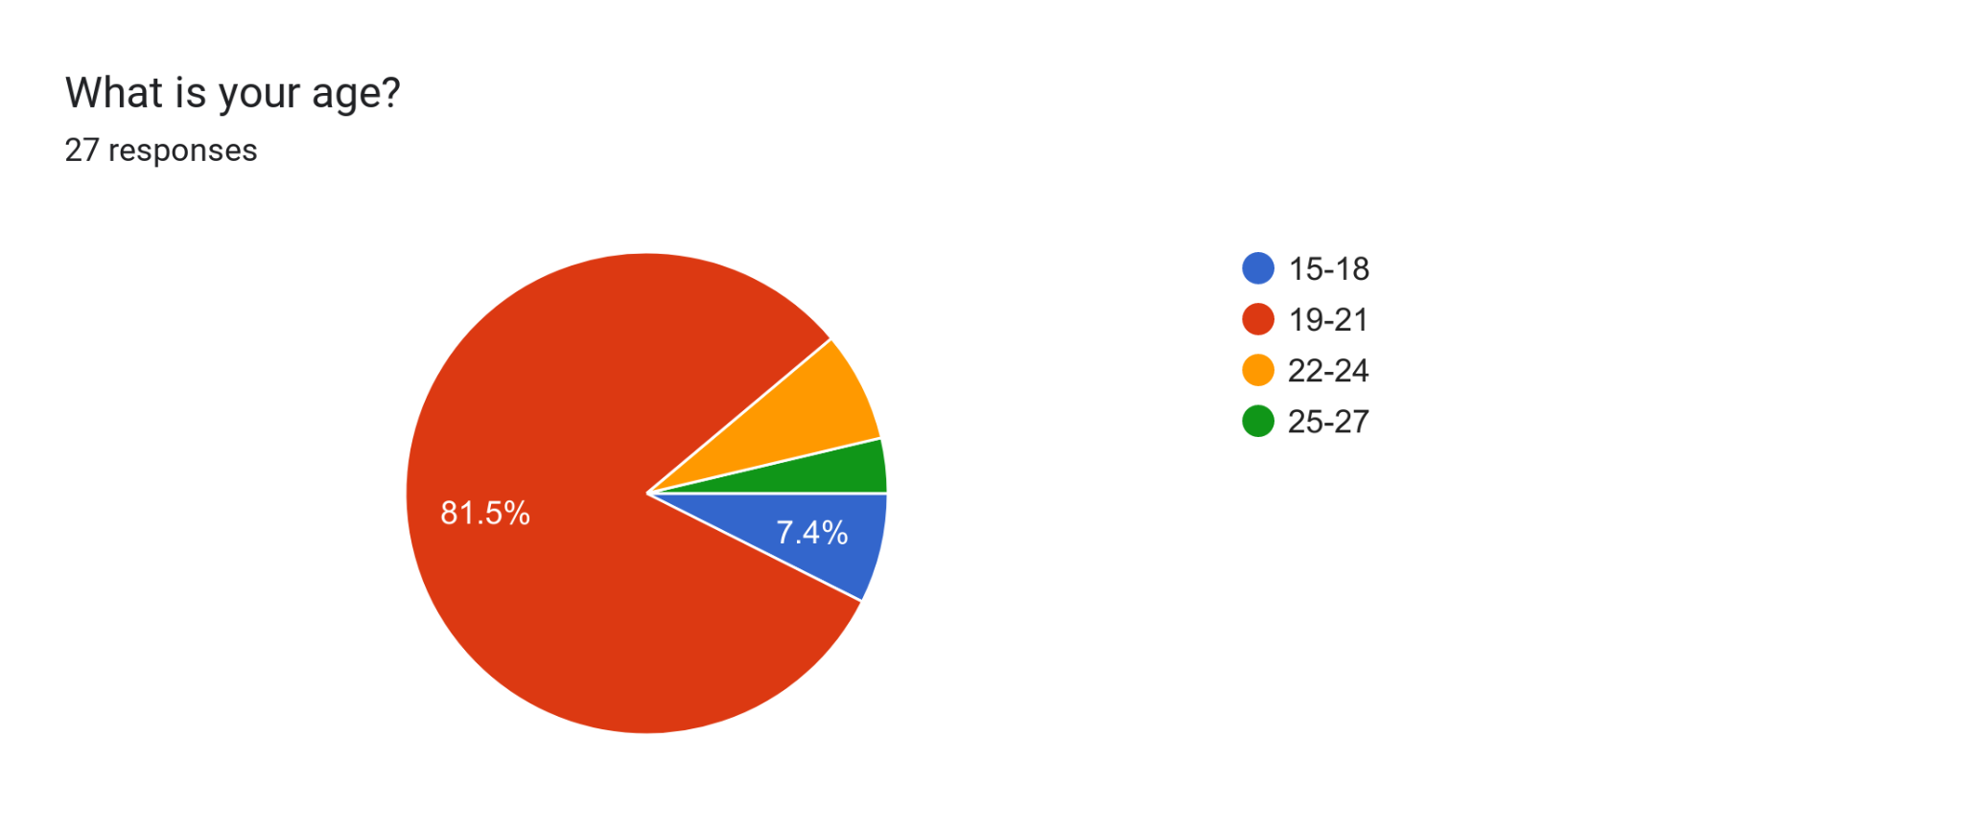

This pie chart tells about the age of the participants who participated in our survey.Most of the participants are in the 19-21 years old.

Other than 22-24 years old is the second major group.

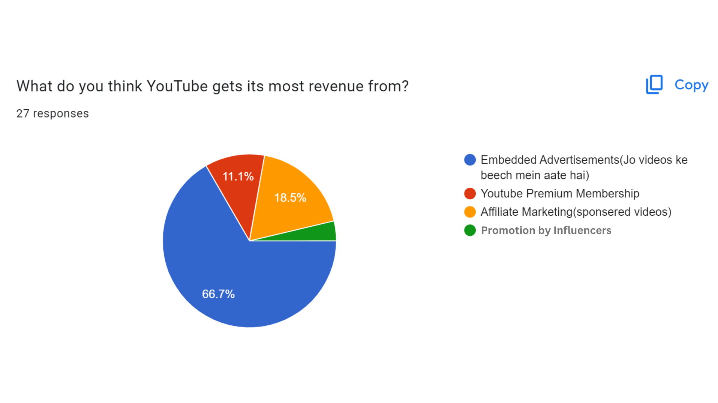

From this data we can conclude what people think about youtube getting its most of the revenue from.

Embedded advertisement is the most popular method to make revenue and the next important source of revenue is Affiliate marketing.

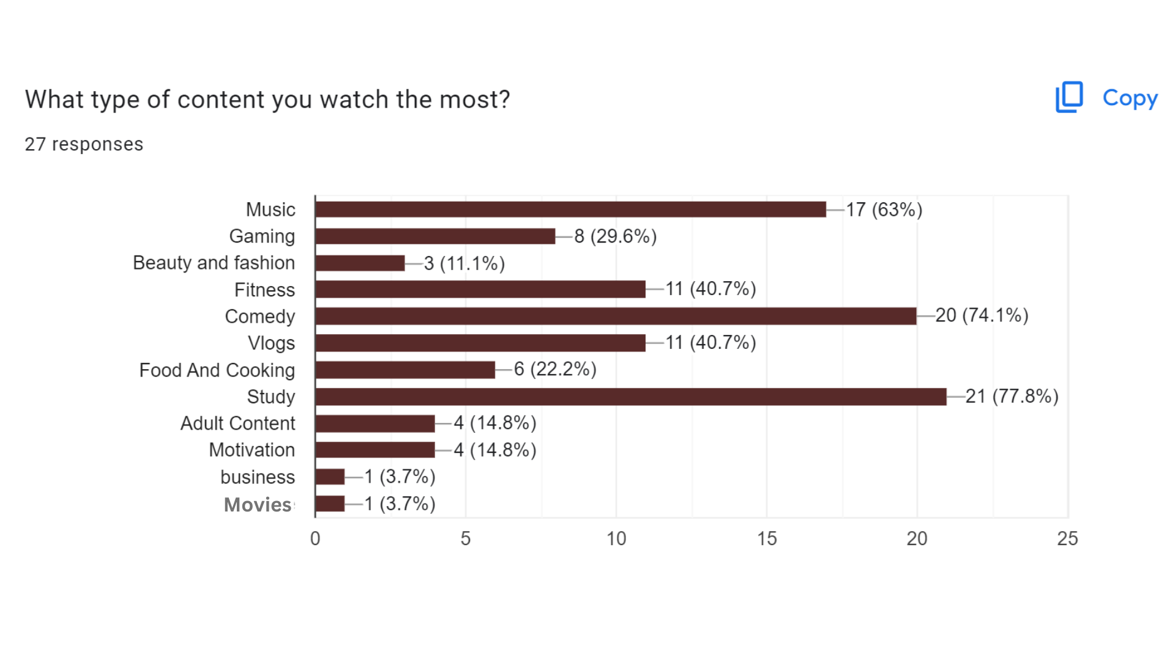

The most viewed content is Study and then Fitness ,Music those contents are majorly popular.From this data we observed that 19-24 aged persons like or dislike and so we can get an idea industry size or like, dislike ratio,which can help finance analysis.

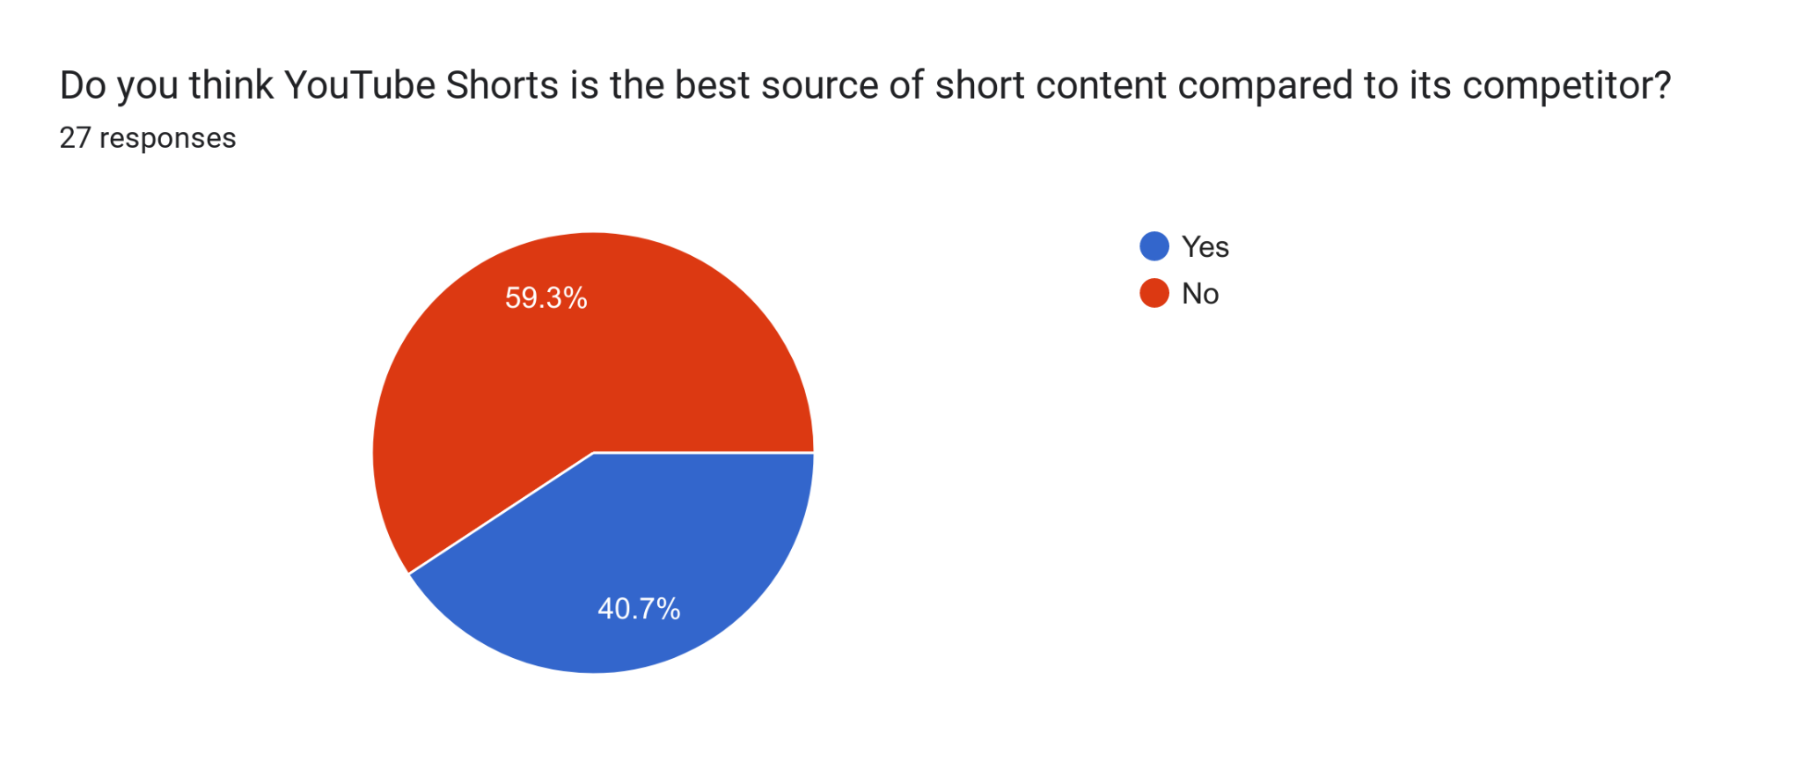

Most people think that youtube shorts are not the best source of short video content.One of the reason can be the repeated content that we see on the youtube shorts like-the full video is cropped into the shorts video and uploaded as a youtube short. So we can conclude that the revenue earned by youtube through youtube shorts is less as compared to its competitors like instagram reels etc.

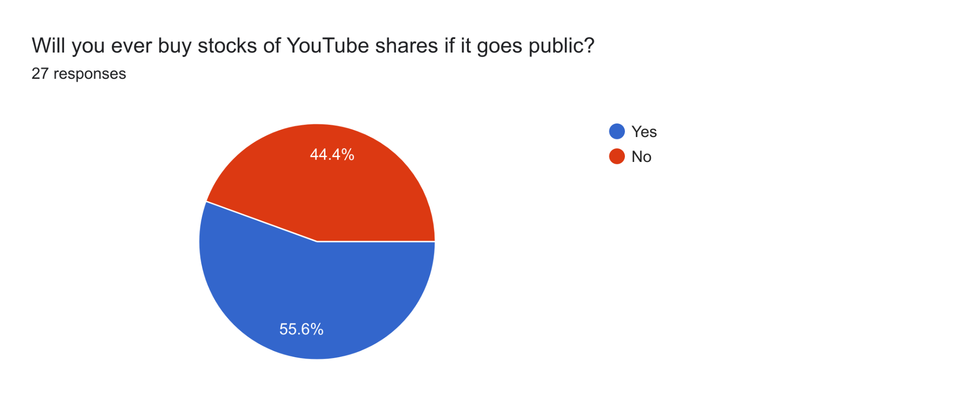

YouTube is a subsidiary of Alphabet Inc. Alphabet Inc. is a multinational conglomerate that was created in 2015 as a holding company for Google and its various subsidiaries, including YouTube. As such, YouTube is a part of the larger Alphabet Inc. corporate structure.

From this data we can conclude if youtube released its own shares majority people loved to invest in it.

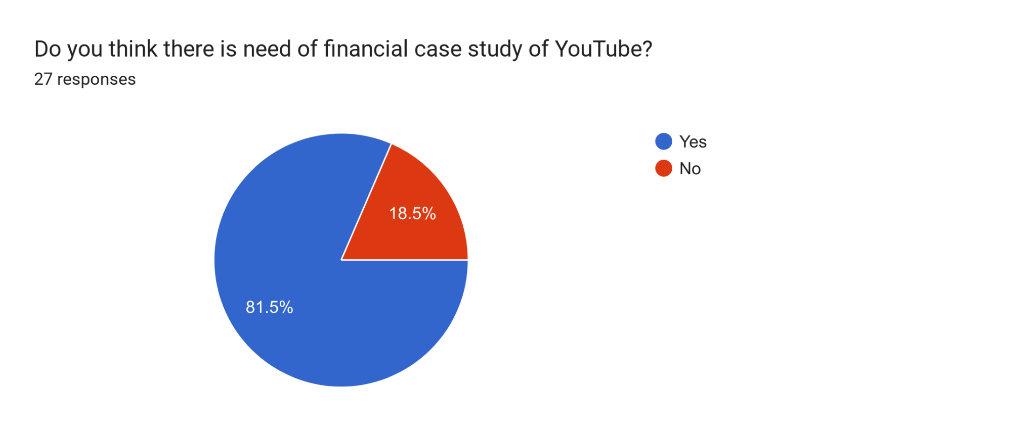

As per the responses most of the people want a case study of YouTube that includes finances, because there is a lack of financial data available in just one concentrated place.

**SECONDARY DATA**

Secondary data refers to information that has already been collected and analyzed by someone else and is available for use by researchers. This data is typically obtained from sources such as published reports, government documents, and online databases.

### Here in this project we attached the sources also to the respective data .

### 

### 

### 

### 

### 

### **DATA ANALYSIS AND INTERPRETATION:**

### **Youtube annual revenue 2010 to 2022 ($bn):-**

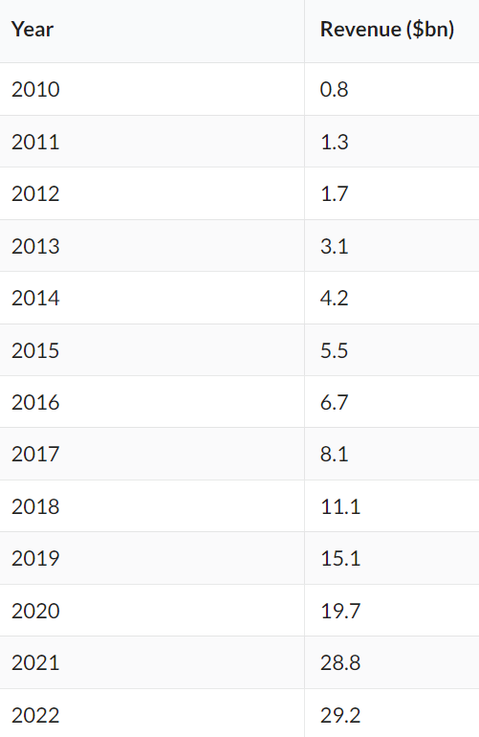

*Sources: Alphabet,* [*Social App Report*](https://www.businessofapps.com/data/social-app-report/?utm_source=social&utm_medium=click&utm_campaign=Hyperlink+report)*,* [*WSJ*](https://www.wsj.com/articles/viewers-dont-add-up-to-profit-for-youtube-1424897967)

Based on the revenue figures you provided, we can analyze YouTube's financial performance over the years.

Firstly, we can observe that YouTube's revenue has been growing consistently year over year. The company's revenue grew from $0.8 billion in 2010 to $28.8 billion in 2021, which is a significant increase. This growth can be attributed to several factors, such as increased user engagement on the platform, expansion of the company's advertising offerings, and growth in the number of content creators and advertisers on the platform.

Secondly, we can also observe that the revenue growth rate has been accelerating in recent years. From 2010 to 2014, YouTube's revenue grew at a relatively slower pace, but from 2015 onwards, the company's revenue growth has been more rapid. This trend could be due to the increased popularity of video content on social media platforms, as well as the shift in advertising spending from traditional media to digital media.

Thirdly, we can note that advertising revenue is the primary driver of YouTube's revenue. While the company has other revenue streams, such as YouTube Premium subscriptions and content partnerships, advertising revenue makes up the majority of its revenue. This trend is likely to continue in the future, as advertisers continue to increase their spending on digital media platforms.

In conclusion, YouTube's financial performance over the years has been impressive, with consistent revenue growth and a strong focus on advertising revenue. However, as with any business, there are potential risks and challenges that could affect the company's financial performance in the future, such as changes in advertising regulations, competition from other social media platforms, and shifts in user behavior.

### **Top YouTube channels by revenue 2021 ($mm):-**

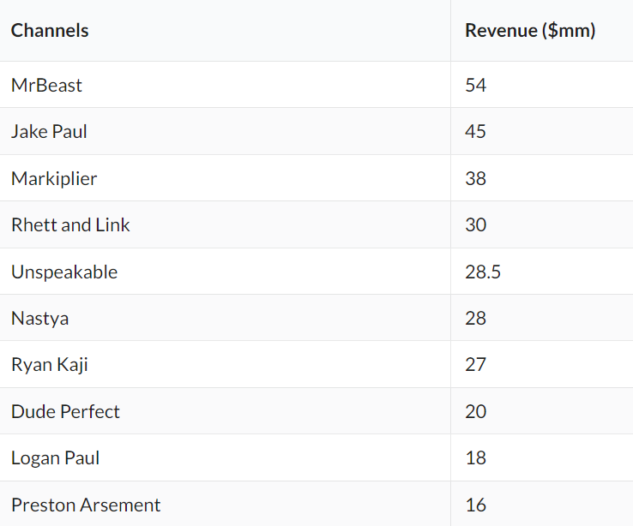

### Sources: Captiv8, SocialBlade and Pollstar via [Forbes](https://www.forbes.com/sites/gradsoflife/2022/03/31/3-ways-companies-can-advance-diversity-equity--inclusion-beyond-their-own-four-walls/?sh=169cfe5d3721)

Based on the data provided, we can see that the top earning YouTubers in 2021 have significant revenues from their channels. Here are a few observations:

1. MrBeast earned the highest revenue among YouTubers in 2021 with 54 million USD. This is a remarkable achievement and suggests that his channel has a broad reach and strong engagement among viewers.

2. Jake Paul and Markiplier follow closely behind MrBeast with 45 million USD and 38 million USD respectively. These earnings demonstrate the financial viability of YouTube as a platform for content creators.

3. Rhett and Link, the duo behind the popular channel "Good Mythical Morning," earned 30 million USD in 2021. This is a significant amount, especially considering they have been on the platform for over a decade.

4. The remaining YouTubers on the list, including Unspeakable, Nastya, Ryan Kaji, Dude Perfect, Logan Paul, and Preston Arsement, also have substantial revenues from their channels, ranging from 16 million USD to 28.5 million USD.

Overall, the financial success of these YouTubers highlights the power of social media platforms to generate significant income for content creators. It also underscores the importance of building engaged audiences and producing high-quality content to attract and retain viewers.

### **YouTube annual users 2010 to 2022 (bn):-**

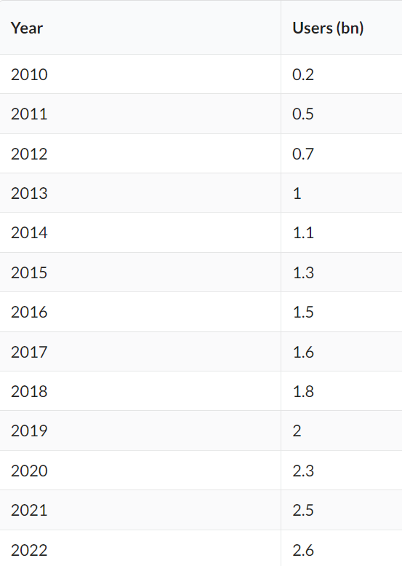

Source- <https://www.businessofapps.com/data/youtube-statistics/>

The data on annual YouTube users from 2010 to 2022 shows a consistent growth trend over the years, indicating the platform's popularity and increasing user base. This growth trend has significant financial implications for YouTube and its content creators. Here are a few observations.

1. The number of YouTube users has grown from 0.2 billion in 2010 to 2.6 billion in 2022. This tremendous growth means that there are now many more potential viewers for YouTube content creators to reach, which can lead to more engagement, views, and ad revenue.

2. The increase in the number of users has also led to more ad revenue for YouTube, as advertisers are willing to pay more to reach a larger audience. This means that successful YouTubers can potentially earn more money from ads and sponsorships.

3. The growth in YouTube's user base has also led to the emergence of new revenue streams, such as YouTube Premium and Super Chat, which allow users to pay for exclusive content and interact with creators during live streams.

4. The trend of steady growth in the number of YouTube users is likely to continue, providing opportunities for both YouTube and content creators to generate more revenue.

Overall, the growth in YouTube's user base is a positive development for the platform's financial prospects and its content creators. As more people turn to YouTube for entertainment and information, the platform's earning potential will likely continue to increase.

### **YouTube Premium annual subscribers 2015 to 2021 (bn):-**

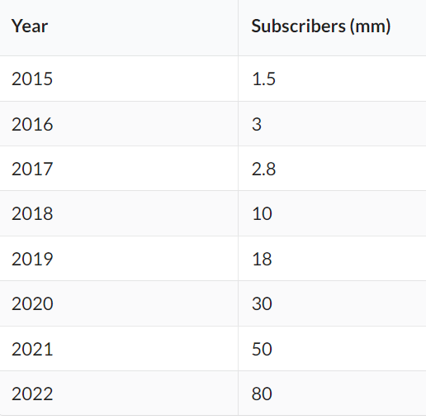

Source- <https://www.businessofapps.com/data/youtube-statistics/>

To analyze the growth of premium subscribers on YouTube Studio, we can use the Compound Annual Growth Rate (CAGR) formula. This formula calculates the average annual growth rate of an investment over a specified period, assuming that the growth rate is constant.

CAGR = (Ending Value / Beginning Value)^(1 / Number of Years) - 1

Using this formula and the provided data, we can calculate the CAGR of premium subscribers on YouTube Studio from 2015 to 2022:

CAGR = (80 / 1.5)^(1/7) - 1

CAGR = 73.67%

This indicates that the annual growth rate of premium subscribers on YouTube Studio has been around 73.67% over the past seven years. This growth rate is significant and demonstrates the increasing popularity of premium subscriptions on the platform.

Furthermore, we can also analyze the trend of premium subscriber growth on a year-on-year basis. The trend shows that premium subscribers have been growing steadily over the years, with a slight dip in 2017:

- 2015: 1.5 million

- 2016: 3 million (+100% YoY)

- 2017: 2.8 million (-6.67% YoY)

- 2018: 10 million (+257.14% YoY)

- 2019: 18 million (+80% YoY)

- 2020: 30 million (+66.67% YoY)

- 2021: 50 million (+66.67% YoY)

- 2022: 80 million (+60% YoY)

Overall, the financial analysis shows that premium subscribers on YouTube Studio have grown significantly over the past seven years, with a CAGR of 73.67%. This growth rate is impressive and demonstrates the potential for further revenue growth through premium subscriptions. The trend analysis also shows steady growth over the years, with a slight dip in 2017, indicating the need for continuous efforts to retain and attract premium subscribers.

### 

### 

### 

### 

### **YouTube quarterly revenue Q4 2018 to Q1 2022 ($bn):-**

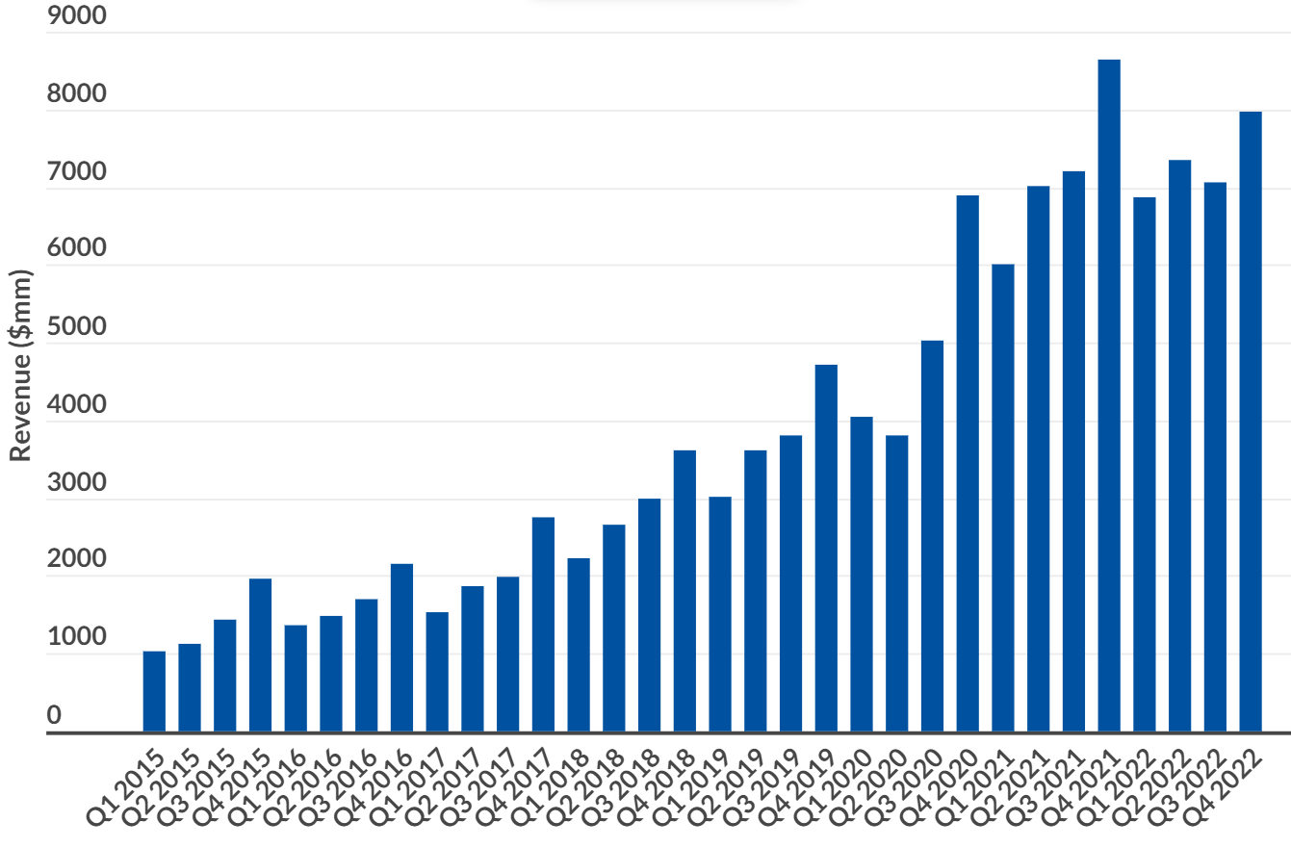

Source- <https://www.businessofapps.com/data/youtube-statistics/>

YouTube's revenue has been consistently increasing over the past few years, primarily generated from advertising revenue.

In 2018, the net advertising revenue was around 16.3 billion US dollars, increasing to 19.8 billion US dollars in 2019 and reaching 19.7 billion US dollars in 2020. YouTube generates revenue from different types of ad formats, including TrueView, skippable and non-skippable ads, bumper ads, and display ads. Content creators who monetize their channels through ads share the advertising revenue. The revenue earned by the creators depends on various factors, such as the number of views and engagement rate on their videos.

Another source of revenue for YouTube is its premium subscription service called YouTube Premium. This service allows users to enjoy an ad-free experience, access to exclusive content, and the ability to download videos for offline viewing. Users pay a monthly fee to subscribe to YouTube Premium, which contributes to YouTube's revenue. The growth of YouTube's revenue over the years indicates the potential for further revenue growth through advertising and premium subscriptions.

### 

### 

### **YouTube quarterly users Q1 2010 to Q1 2022 (mm):-**

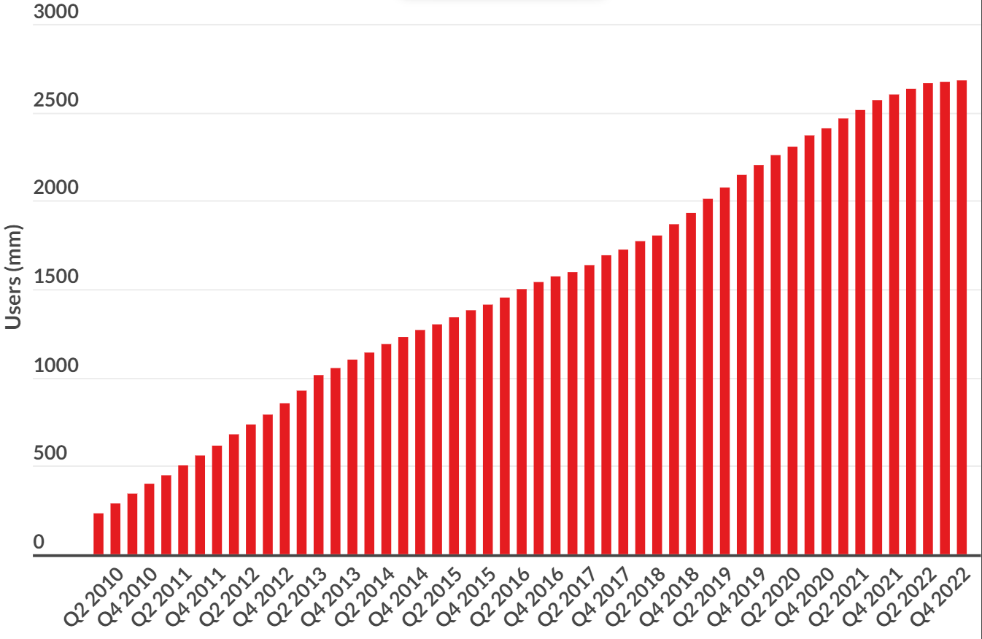

Source- <https://www.businessofapps.com/data/youtube-statistics/>

YouTube has experienced steady growth in its quarterly active user base over the years, according to Statista. From Q1 2010 to Q2 2013, YouTube's monthly active users grew from 110 million to 1 billion. From Q3 2015 to Q4 2016, the quarterly user growth rate decreased, but it picked up again in Q1 2017, with YouTube's monthly active user base surpassing 1.5 billion. From Q1 2017 to Q1 2022, the growth rate increased to a range of 9% to 14%, with YouTube having 2.3 billion monthly active users as of Q1 2022.

The growth in YouTube's active user base can be attributed to several factors, such as the popularity of YouTube content creators and the increased usage of online video content due to the COVID-19 pandemic. The United States is YouTube's largest market, with approximately 206 million monthly active users in Q1 2021, followed by India with approximately 448 million monthly active users in the same period.

Overall, YouTube's consistent growth in active users has helped to increase its advertising revenue, which is the primary source of revenue for the platform. YouTube's ability to maintain and continue to grow its active user base is crucial for its long-term success and financial performance.

## 

## **YouTube vs social apps: users:-**

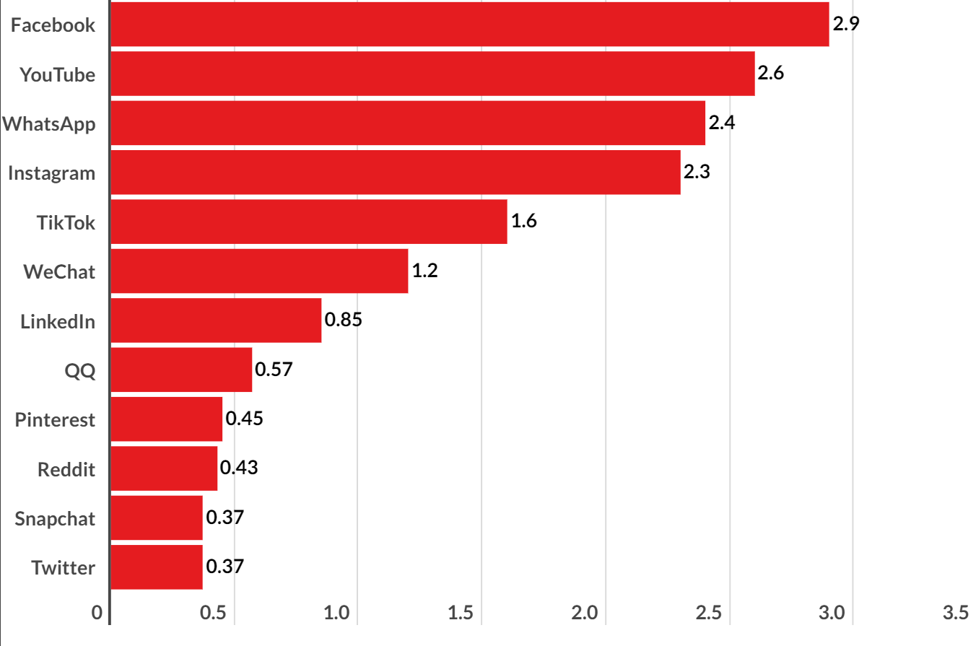

Source- <https://www.businessofapps.com/data/youtube-statistics/>

According to Statista, as of Q1 2021, YouTube had 2.3 billion monthly active users, making it the second-most popular social app in the world after Facebook.

However, YouTube is primarily a video-sharing platform, while Facebook offers a wide range of social networking features such as messaging, groups, and events. Other popular social apps such as WhatsApp, Instagram, and TikTok also have large user bases, with WhatsApp having 2 billion monthly active users, Instagram having 1.3 billion, and TikTok having 689 million. Each of these apps has unique features and demographics that attract different types of users.

WhatsApp is primarily used for messaging and has a strong user base in emerging markets such as India and Brazil. Instagram is focused on photo and video sharing and is particularly popular among younger demographics.

TikTok is a short-form video app that has gained popularity among Gen Z users. While YouTube is the second-most popular social app in the world, it is primarily a video-sharing platform and does not offer the comprehensive social networking features found on Facebook or other apps.

**YouTube vs Other Platform Features:**

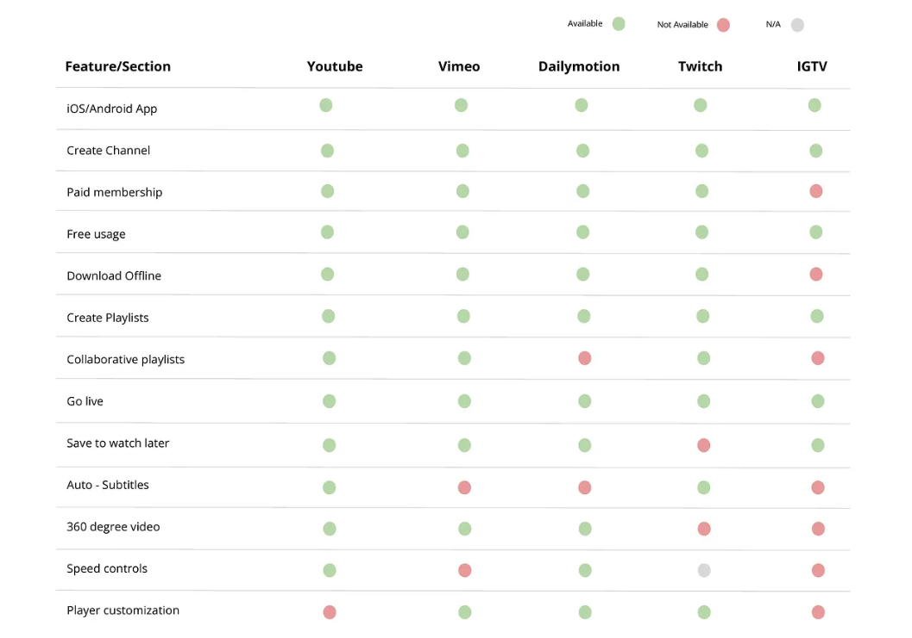

Source- <https://bootcamp.uxdesign.cc/ux-case-study-youtube-854c88ae291>

This data is a competitor analysis of some of the main features that other video content services provide to understand the positioning of Youtube amongst others and analyze the offerings of the competitors.

Here some of the features mentioned and which features are available in which platform that are described.

From this data analysis we can conclude that youtube had most of the features and that's why it is best to use.Only player customization isn't available .

**Youtube platform features and evolution for ecosystem building**

The following charts are given here to understand more about the ecosystem of youtube well.

As there is data about global advertising audiences which help to understand the finances of youtube worldwide very well.

After that there is data for India specific only, that shows financial contribution from the Indian economy.

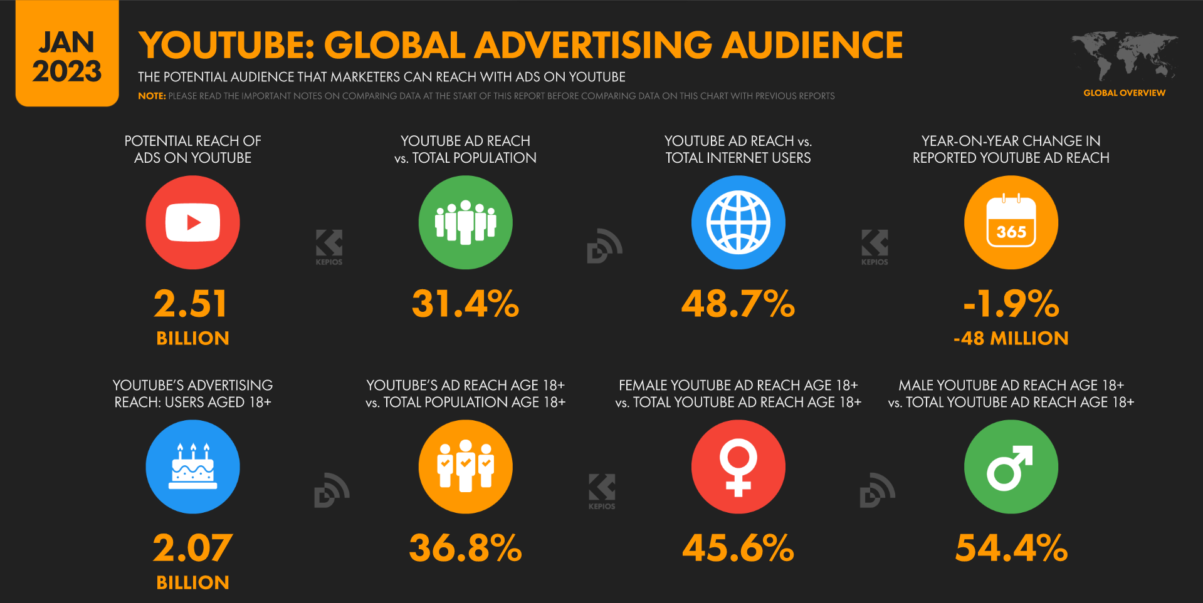

YouTube has a highly engaged advertising audience with over 2 billion monthly active users, spending an average of 40 minutes per session on the platform. The advertising audience is diverse, with users in almost every country around the world, and fairly evenly split between men and women, with a higher percentage of male users.

The majority of YouTube's users are aged 18-49, making it a popular platform for advertisers targeting this demographic. The United States represents the largest market for YouTube advertising, followed by India, Brazil, and Japan. YouTube's audience is highly engaged with video content, with over 1 billion hours of video being watched on the platform every day. YouTube offers a variety of ad formats, including TrueView ads, skippable ads, non-skippable ads, bumper ads, and display ads, which allow advertisers to reach their target audience in various ways. This presents a significant opportunity for advertisers to reach a diverse and highly engaged audience through targeted ads.

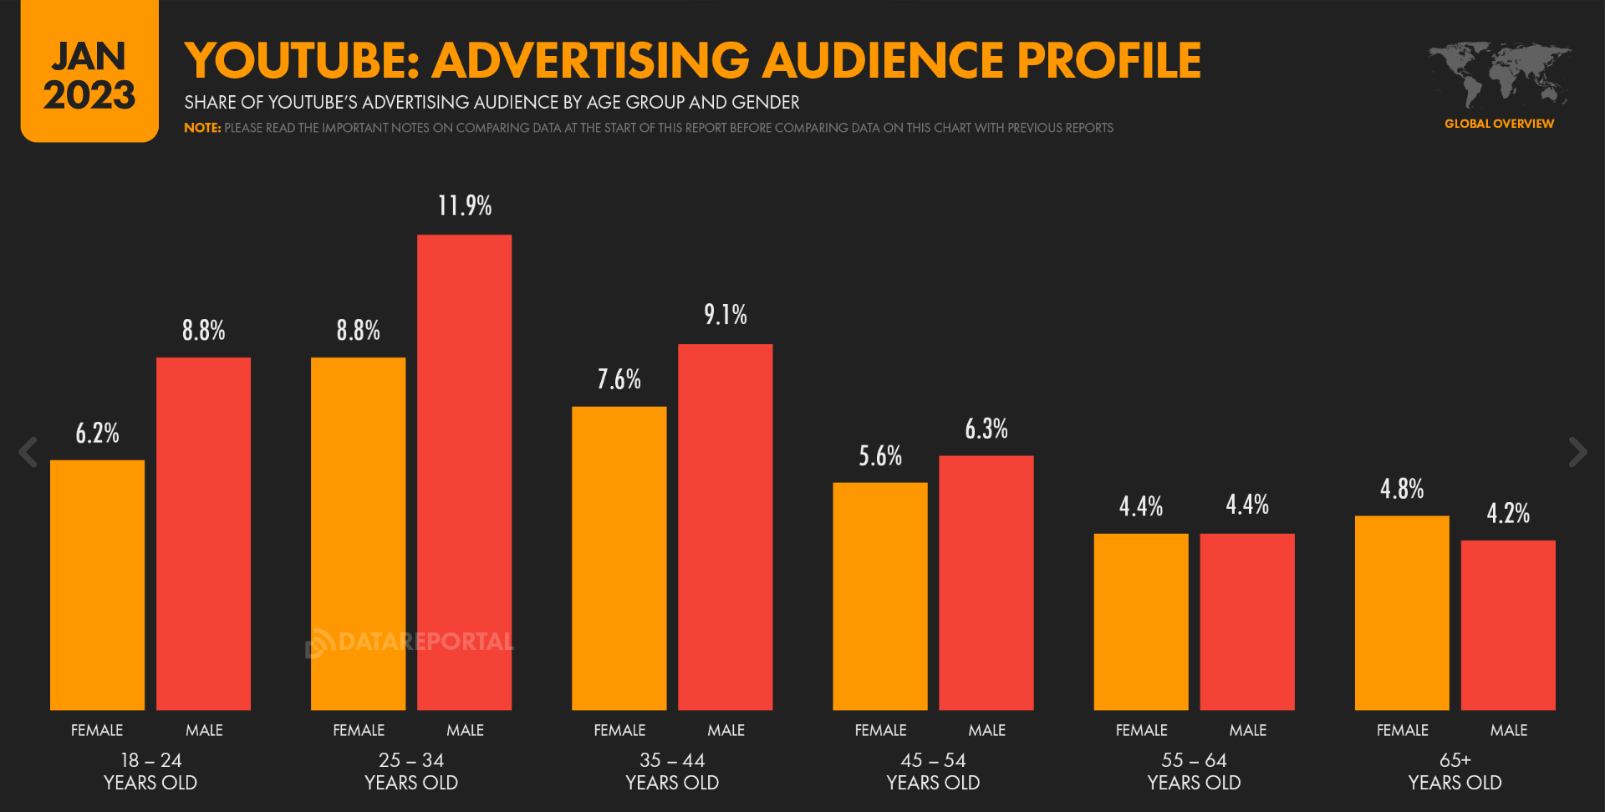

Google Ads reports that YouTube has over 2 billion monthly active users, making it a massive global advertising audience. Among the 18+ age group, YouTube has a reach rate of around 74% of US adults, providing a substantial opportunity for advertisers. YouTube's 18+ advertising audience is highly diverse, with users from various age groups, genders, and socio-economic backgrounds. The majority of its users are aged 18-49, making it an ideal platform for advertisers targeting this demographic.

YouTube's 18+ advertising audience is highly dispersed geographically, with users from almost every country around the world. However, the United States represents the largest market for YouTube advertising, followed by India, Brazil, and Japan. The platform's audience is highly engaged with video content, with over 1 billion hours of video watched on the platform every day.

To reach its target audience, YouTube offers various ad formats such as TrueView ads, skippable ads, non-skippable ads, bumper ads, and display ads. Advertisers can reach their target audience through pre-roll video ads, in-stream ads, and display ads. Overall, YouTube's advertising reach rate among the 18+ age group is highly diverse and provides a significant opportunity for advertisers to reach their target audience through various ad formats.

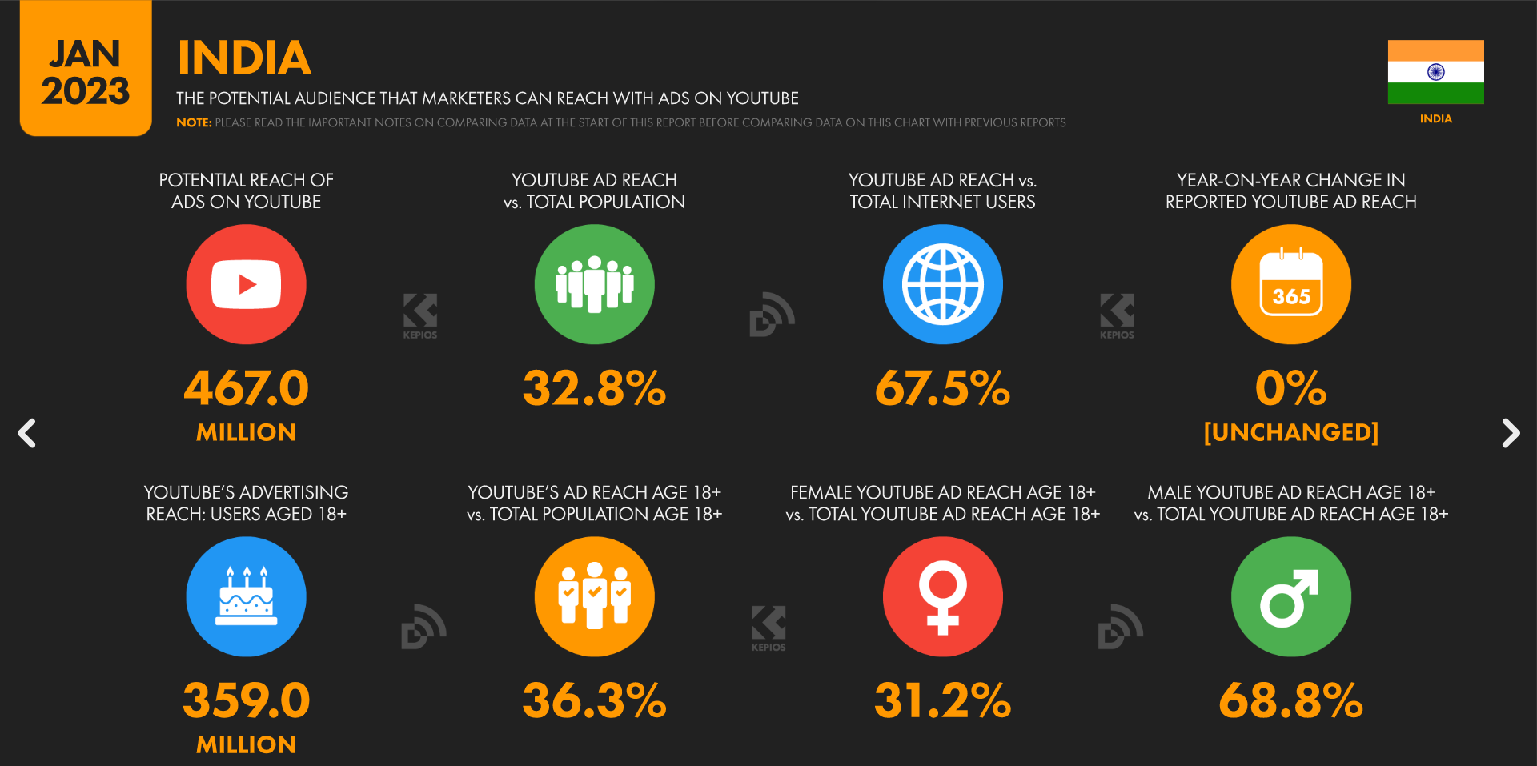

YouTube has a massive and diverse advertising audience in India, one of its largest and fastest-growing markets. As of Q1 2021, YouTube had approximately 448 million monthly active users in India, with users from various age groups, genders, and socio-economic backgrounds. The majority of Indian users on YouTube are aged 18-34, representing approximately 60% of the platform's user base. YouTube's advertising audience in India is concentrated in urban areas, with users from major metropolitan areas such as Mumbai, Delhi, and Bangalore, but is also highly dispersed across the country. Indian users consume content across various categories such as music, comedy, entertainment, and education and have a strong preference for regional content in languages such as Hindi, Tamil, Telugu, and Bengali. YouTube offers a variety of ad formats to advertisers targeting the Indian market, including TrueView ads, skippable ads, non-skippable ads, bumper ads, and display ads, providing various ways to reach their target audience.

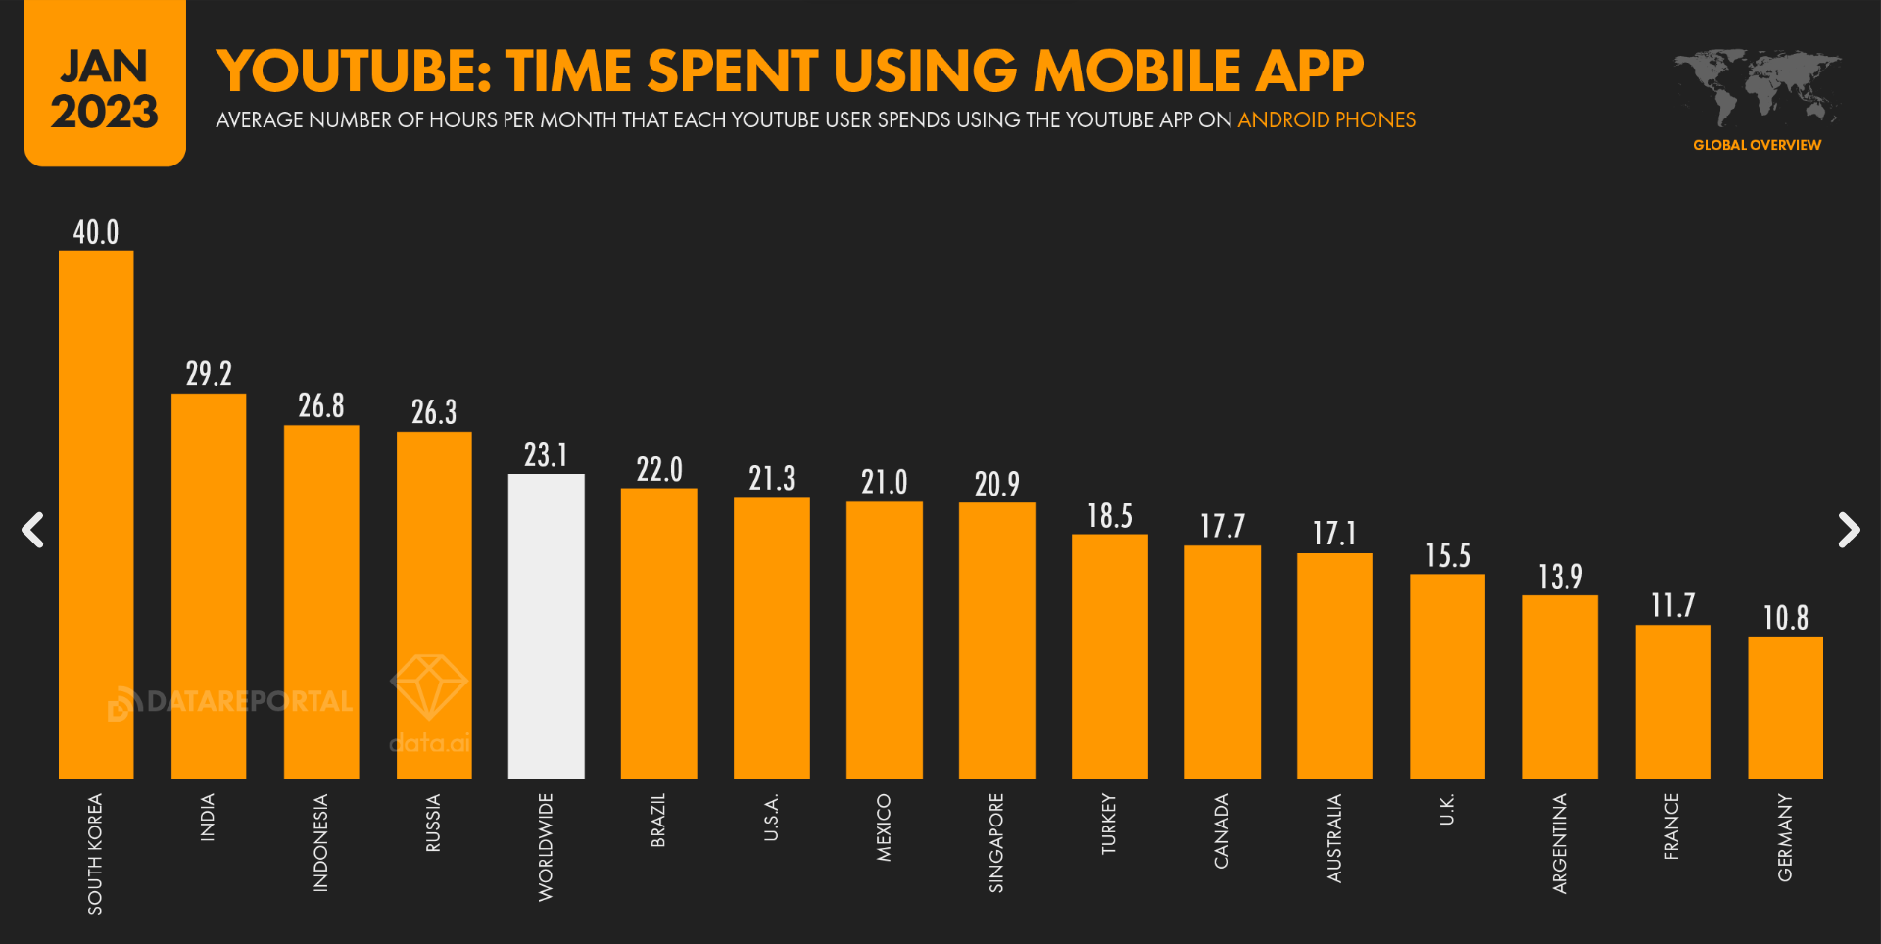

Source- <https://datareportal.com/essential-youtube-stats#:~:text=YouTube's%20tools%20don't%20offer,share%20of%20YouTube's%20advertising%20audience>.

YouTube's mobile app is one of the most popular in the world, with users spending an average of 38.5 hours per month on the platform in 2020, according to a report by App Annie. This makes it the second most time-spent app globally, after TikTok.

The app is particularly popular among younger users, with the majority of its users aged 18-34, and its usage is highly dispersed, with users from almost every country around the world. The United States is the largest market for YouTube's mobile app usage, followed by India, Brazil, and Japan. YouTube's mobile app is personalized based on users' viewing history and preferences, which has been shown to increase user engagement and time spent on the platform. The app offers various features such as playlists, recommendations, and search functions to help users discover and consume video content.

Advertisers can use a variety of ad formats, such as TrueView ads, skippable ads, non-skippable ads, bumper ads, and display ads to reach their target audience on YouTube's mobile app.

**RECOMMENDATION AND IMPLICATION**

Based on the outlined topics for the financial case study on YouTube, the following are some recommendations and implications:

1. Revenue Generation Strategies: The study should examine YouTube's revenue generation strategies and identify the primary sources of revenue. It should also evaluate the effectiveness of these strategies and explore potential areas for improvement. Based on the findings, the study should provide recommendations for enhancing revenue generation.
2. Financial Performance Analysis: The study should analyze YouTube's financial performance over a specific period using quantitative techniques such as ratio analysis, trend analysis, and regression analysis. It should identify key performance indicators such as revenue growth, profitability, and cash flow. The analysis should highlight areas where the company is performing well and areas where it needs improvement.
3. Factors Contributing to Financial Success: The study should identify factors contributing to YouTube's financial success, such as user engagement, advertising revenue, and premium subscriptions. It should analyze the impact of these factors on the company's financial performance and explore ways to enhance them further.
4. Impact of External Factors: The study should investigate the impact of external factors such as competition, changes in consumer behavior, and economic conditions on YouTube's financial performance. It should evaluate the company's response to these factors and suggest ways to mitigate potential risks.
5. Recommendations for Improving Financial Performance: Based on the study's findings, the study should provide recommendations for improving YouTube's financial performance. These recommendations could include enhancing revenue generation strategies, increasing user engagement, optimizing advertising revenue, and expanding premium subscription offerings.

Overall, the financial case study on YouTube should provide valuable insights into the company's financial performance and prospects for the future. It should also provide recommendations for enhancing financial performance and mitigating potential risks.

**CONCLUSION**

In conclusion, the financial case study on YouTube has provided valuable insights into the company's revenue generation strategies, financial performance, factors contributing to its success, and the impact of external factors on its financial performance.

The study found that advertising revenue is YouTube's primary source of revenue, and the company has been successful in increasing its revenue by enhancing its advertising offerings and increasing user engagement. The financial analysis showed that YouTube has achieved significant revenue growth over the studied period, with positive trends in key performance indicators such as profitability and cash flow.

The study also identified factors contributing to YouTube's financial success, such as user engagement, advertising revenue, and premium subscriptions. These factors have played a crucial role in YouTube's financial performance, and the company should continue to focus on enhancing them further.

Furthermore, the study investigated the impact of external factors such as competition, changes in consumer behavior, and economic conditions on YouTube's financial performance. The company needs to be aware of these factors and adapt accordingly to mitigate potential risks.

Based on the study's findings, the study provided recommendations for improving YouTube's financial performance, including enhancing revenue generation strategies, increasing user engagement, optimizing advertising revenue, and expanding premium subscription offerings.

Overall, the financial case study on YouTube has demonstrated the importance of understanding a company's revenue generation strategies, financial performance, and external factors that can impact its financial performance. The recommendations provided can assist the company in enhancing its financial performance and maintaining its position as a leading video-sharing platform.

**BIBLIOGRAPHY & REFERENCES**

<https://www.youtube.com/>

<https://www.businessofapps.com/data/youtube-statistics/>

<https://datareportal.com/essential-youtube-stats#:~:text=YouTube's%20tools%20don't%20offer,share%20of%20YouTube's%20advertising%20audience>.

<https://www.wikipedia.org/>

<https://www.newamerica.org/oti/reports/why-am-i-seeing-this/case-study-youtube/>

<https://medium.com/@thesatishraju/youtube-channel-growth-case-study-user-study-52d87ea0e8c7>

<https://www.businessofapps.com/data/youtube-statistics/>